How we can initialize NodeJS project?

As we know every NodeJS project consist of NPM packages & we need to install as per requirement and that NPM packages take place in package.json because package.json file track installed pacakges that required to run our project & we need this file to be create before start NODEJS project. Run below command to initialize package.json file.

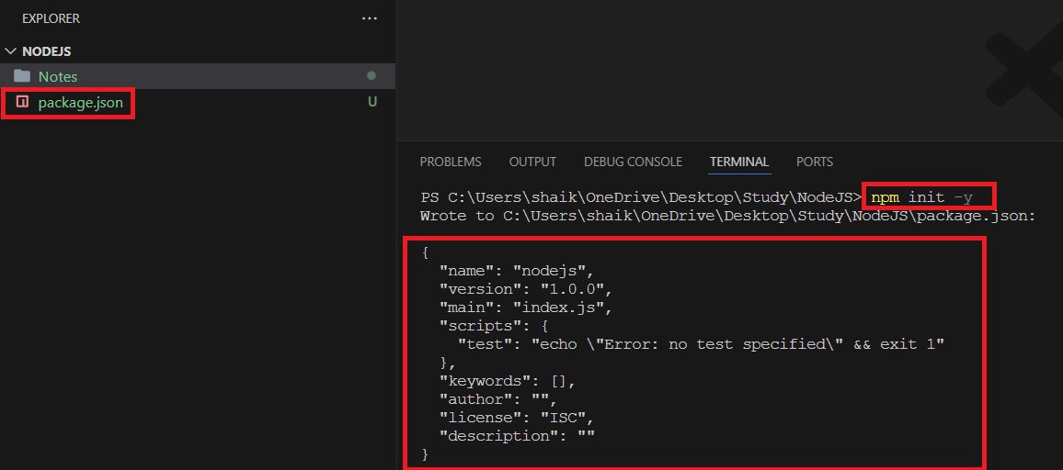

By running ***npm init -y*** command this command create package.json file with default option as shown in screenshot.